**Deploy Python App on GKE**

Follow the steps given below to update your Deployment:

1. Let's update the image to version 1

kubectl set image deployment.v1.apps/python-deployment python-container=gcr.io/vocal-camera-264620/python:v1

**Step 2 : verify app v2 image is used for deployment**

# kubectl describe deployment python-deployment

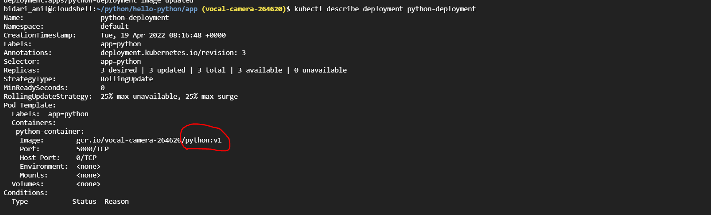

**Step 3 : Describe svc**

# kubectl get svc

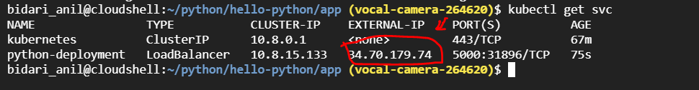

Use the External-ip:5000 on your web browser to verify app is running

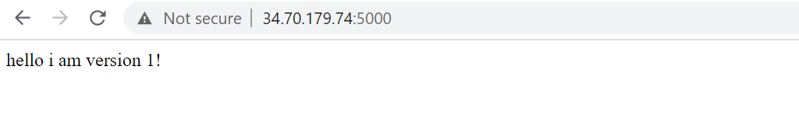

**Step 4 : List the replica set**

# kubectl get rs

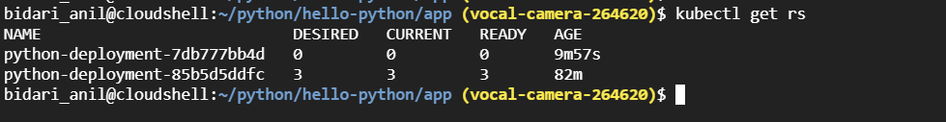

kubectl rollout history deployment/python-deployment

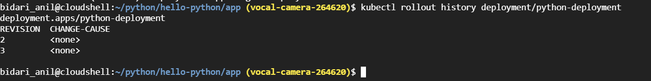

kubectl rollout history deployment/python-deployment --revision=2

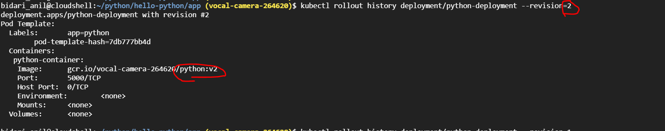

kubectl rollout history deployment/python-deployment --revision=3

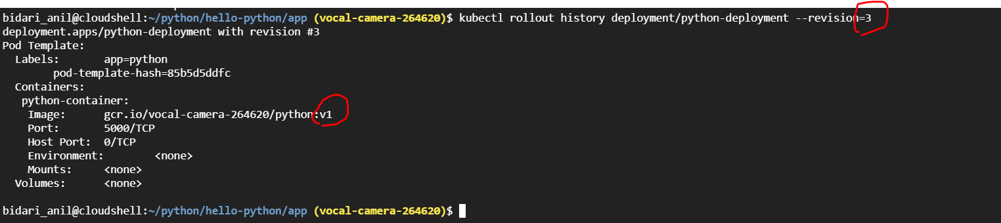

Rolling Back to a Previous Revision

Follow the steps given below to rollback the Deployment from the current version to the previous version, which is version 2.

1. Now you've decided to undo the current rollout and rollback to the previous revision:

kubectl rollout undo deployment/python-deployment

Check if the rollback was successful and the Deployment is running as expected, run:

kubectl get deployment python-deployment



Get the description of the Deployment:

kubectl describe deployment nginx-deployment

We are on revison 4 and back to image version 2

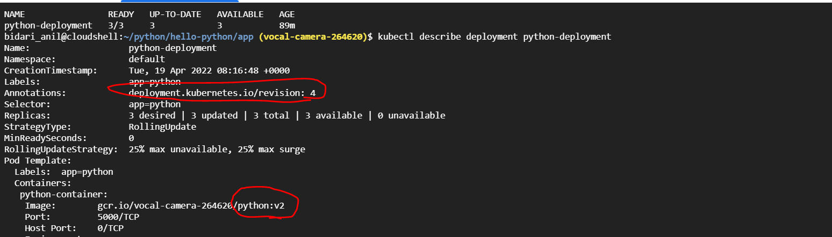

============================ completion of Lab =======================================